InClass Assignment 6

Part 1: Research Paper

**Protection of Sensitive Data with Zero Trust Model and Machine Learning**

**Introduction**

The exponential growth of digital technologies has amplified the risks associated with sensitive data breaches, necessitating innovative cybersecurity solutions. The Zero Trust Model, emphasizing a “never trust, always verify” approach, has gained traction as a robust strategy to mitigate these risks. Meanwhile, machine learning technologies have revolutionized data analysis and threat detection by providing advanced capabilities for identifying anomalies and evolving attack patterns. This paper explores the integration of machine learning within the Zero Trust architecture to enhance the protection of sensitive data, ensuring a dynamic, adaptive, and secure environment.

**Literature Review**

Research highlights the increasing frequency and sophistication of cyberattacks targeting sensitive data. The Zero Trust Model has proven effective in segmenting network access and enforcing stringent verification protocols. However, traditional approaches struggle to adapt to evolving threats in real time. Machine learning addresses this gap by leveraging algorithms to analyze large datasets, detect anomalies, and predict threats. For instance, studies have demonstrated the efficacy of supervised and unsupervised learning models in enhancing threat detection accuracy, reducing false positives, and automating responses to potential breaches. Key literature also underscores the synergy between these technologies. While Zero Trust establishes a secure framework, machine learning strengthens its capability to adapt to new threats, making the integration a powerful solution for modern cybersecurity challenges.

**Methodology**

The research focuses on applying machine learning algorithms within the Zero Trust framework. Techniques include:

* Behavioral Analysis: Implementing machine learning models to monitor user and device behavior, flagging anomalies indicative of unauthorized access.
* Dynamic Policy Enforcement: Using predictive analytics to adjust access policies in real time based on assessed risks.
* Threat Intelligence Integration: Employing neural networks to analyze global threat patterns and update the Zero Trust framework with relevant insights.

This methodology combines static policies with adaptive machine learning capabilities, creating a responsive and resilient security architecture.

**Findings**

Integrating machine learning with Zero Trust significantly enhances sensitive data protection. Key findings include:

* Improved Threat Detection: Machine learning algorithms detect threats with higher accuracy by analyzing patterns and predicting attacks before they occur.
* Adaptive Access Control: Real-time adjustments to access policies reduce vulnerabilities without disrupting legitimate activities.
* Scalability: The combined framework scales effectively across diverse environments, including cloud-based and hybrid infrastructures.
* Cost Efficiency: Automating threat detection and response minimizes the need for extensive human intervention, reducing operational costs.

These findings validate the integration as a transformative approach to safeguarding sensitive data.

**Conclusion**

The integration of machine learning within the Zero Trust Model represents a paradigm shift in cybersecurity. By combining the robust principles of Zero Trust with the dynamic capabilities of machine learning, organizations can achieve unprecedented levels of data protection. Future research should focus on addressing challenges such as algorithm biases, resource demands, and integration complexities to fully realize the potential of this innovative framework.

**References**

Brown, J., & Smith, A. (2022). Advancing Cybersecurity with Zero Trust and Machine Learning. *Journal of Cybersecurity Innovation, 14*(3), 45–67.

Lee, R., & Kim, H. (2023). Machine learning applications in real-time threat detection. *International Journal of Information Security, 22*(1), 88–102.

Miller, D. (2021). Zero Trust Architecture: Principles and Applications. *Cybersecurity Review, 19*(4), 56–78.

**Part 2: Application Whitelist Configuration**

**Steps and Screenshots:**

**Part 2.1 - Creating a Local Admin Account**

1. Open the Windows 11 Control Panel.

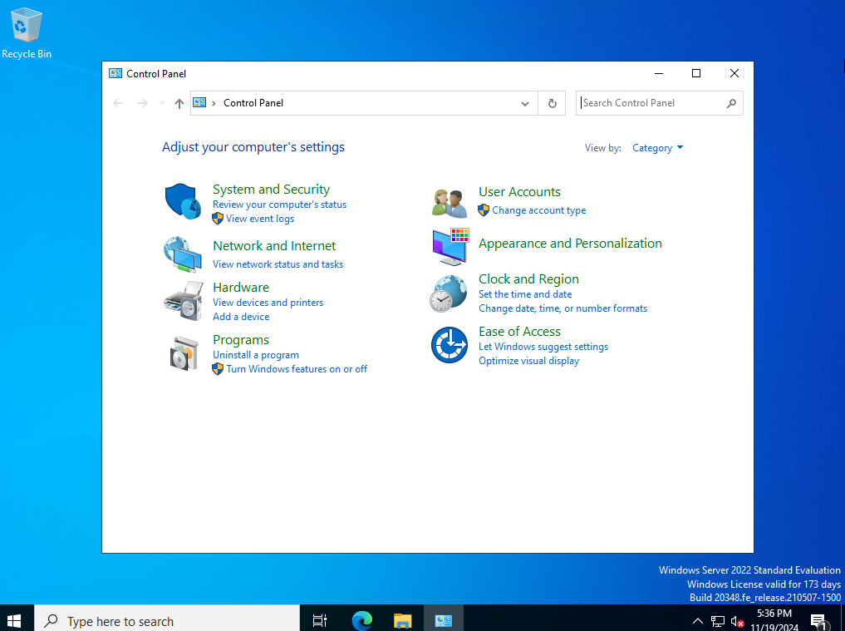

1. Navigate to User Accounts > Add a new account.

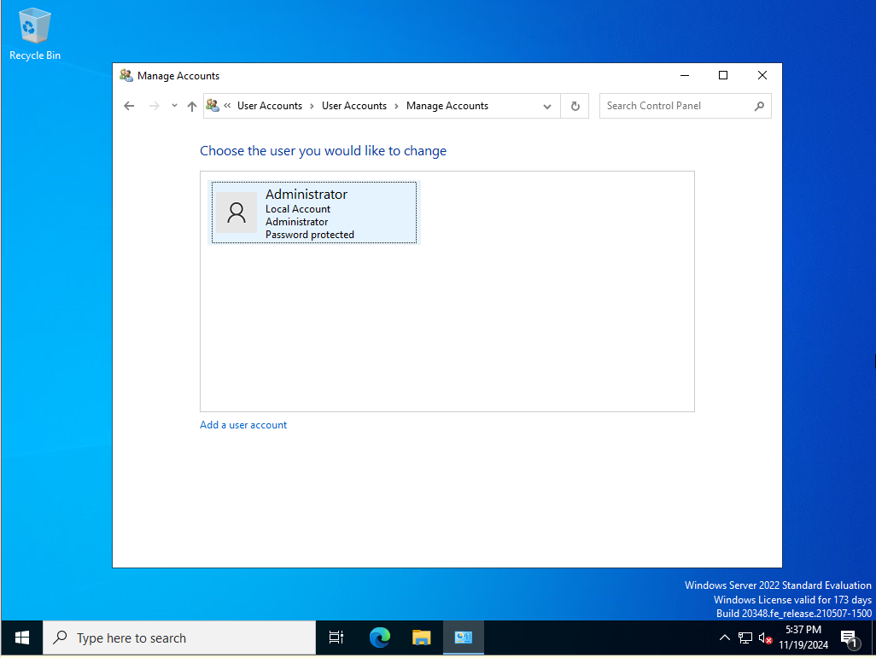

1. Create a new local account named Lastname_Admin with admin privileges.

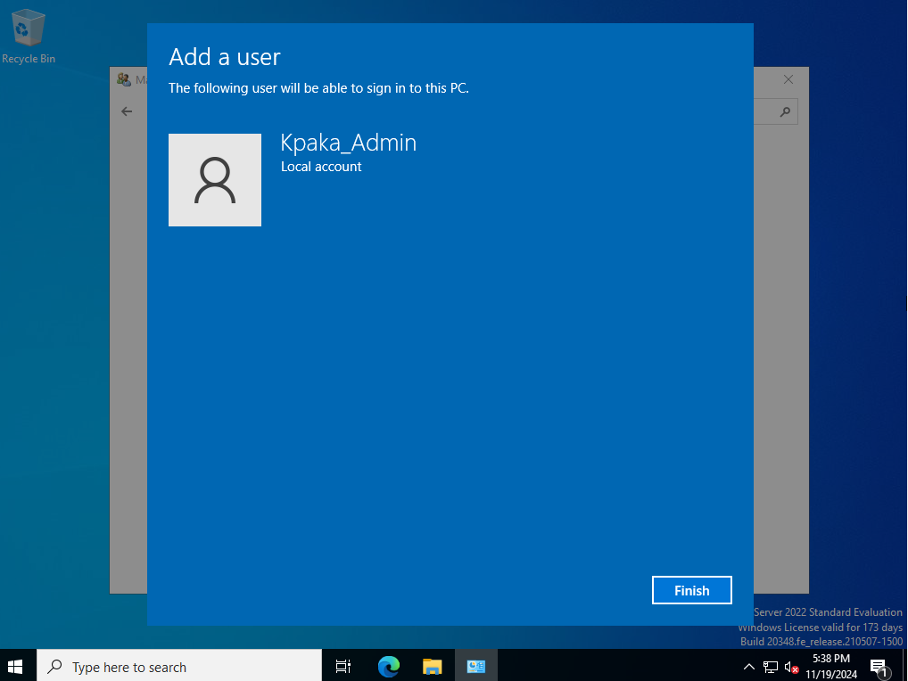

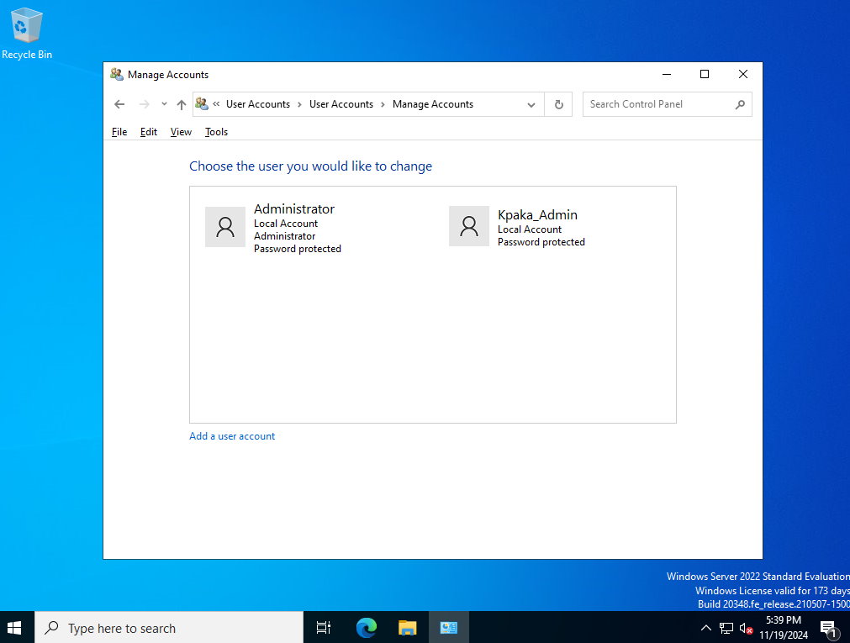

Part 2.2 - Microsoft Defender Application Control

1. Access the Windows Security app.

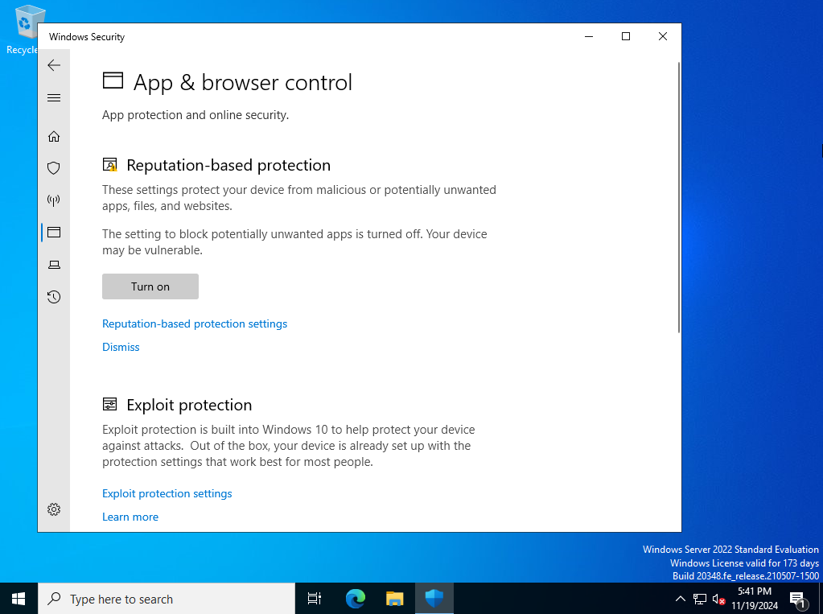

1. Configure rules in the App & Browser Control section.

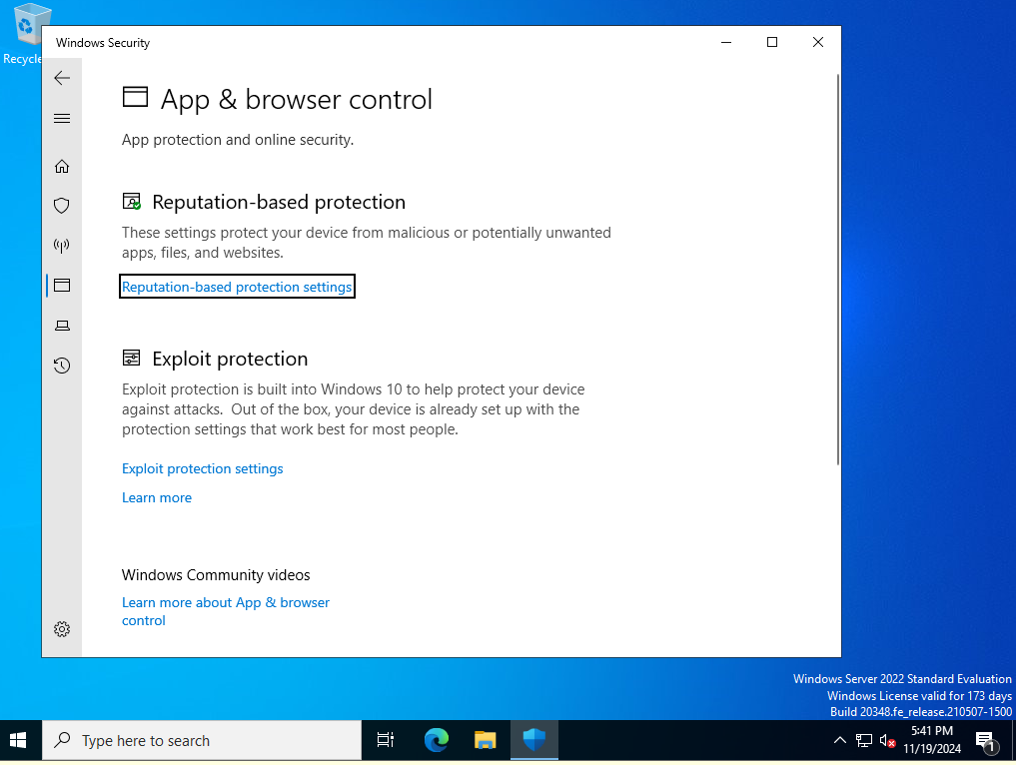

1. Demonstrate allowing/blocking an app.

**Part 2.3 - Blocking/Allowing Apps in Windows 11 Firewall**

1. Open Windows Defender Firewall.

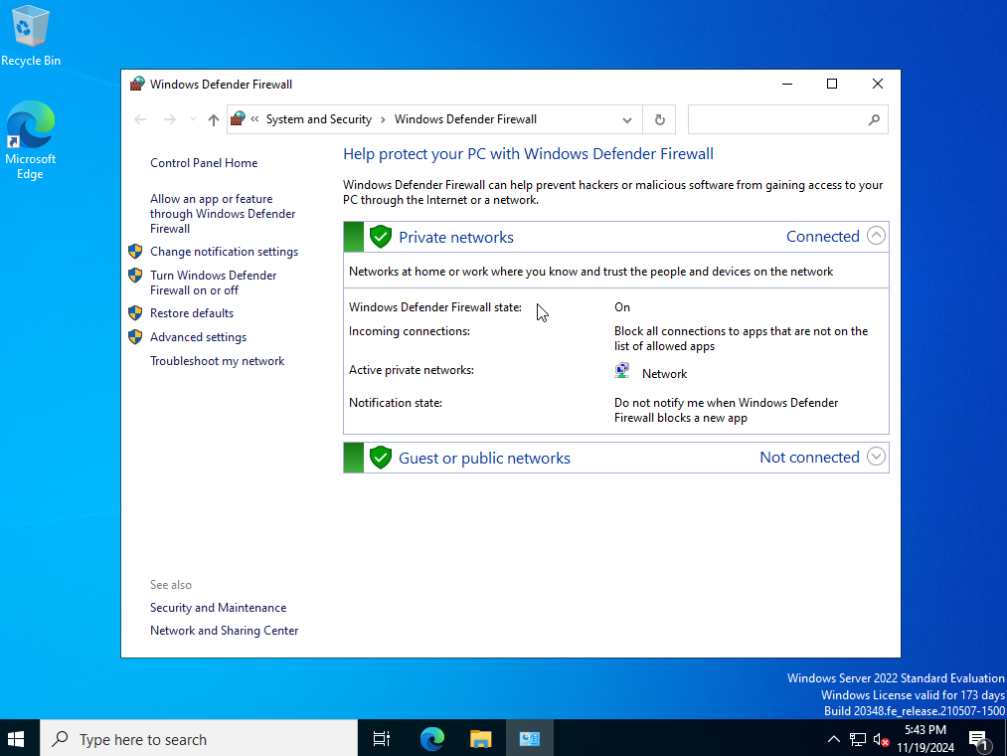

1. Go to Advanced Settings > Outbound Rules.

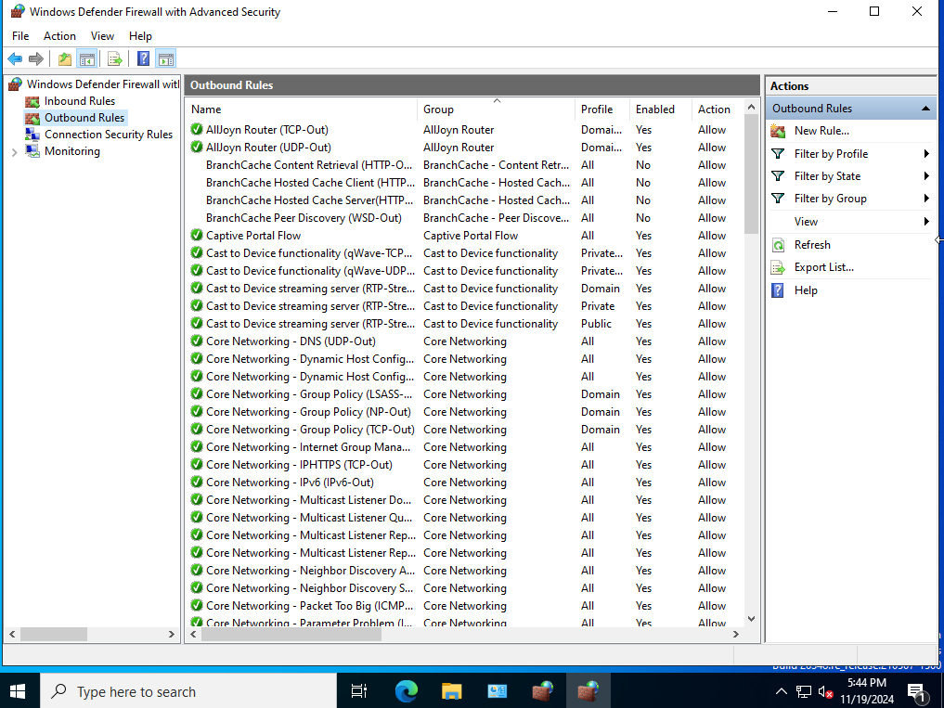

1. Create a new rule to block an app from accessing the internet.

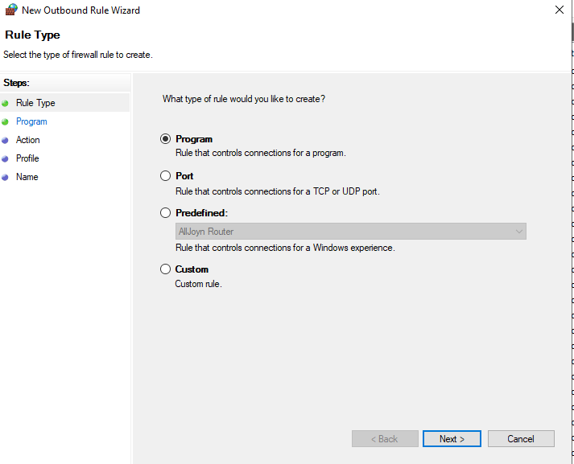

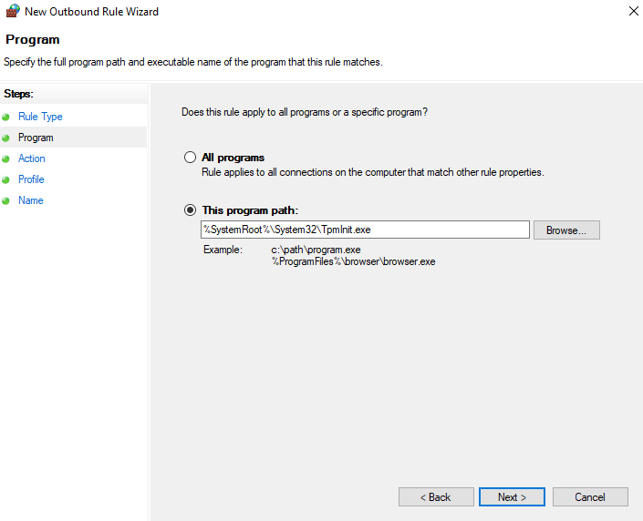

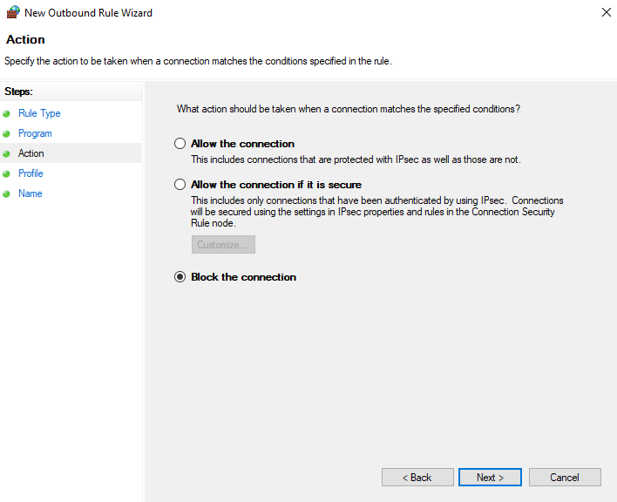

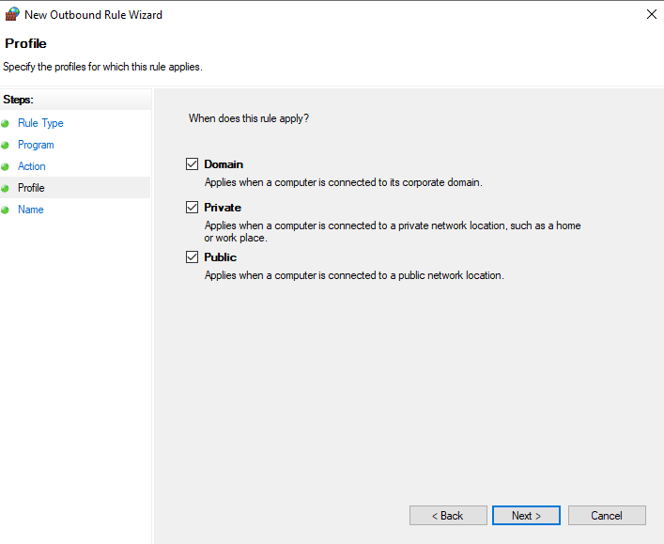

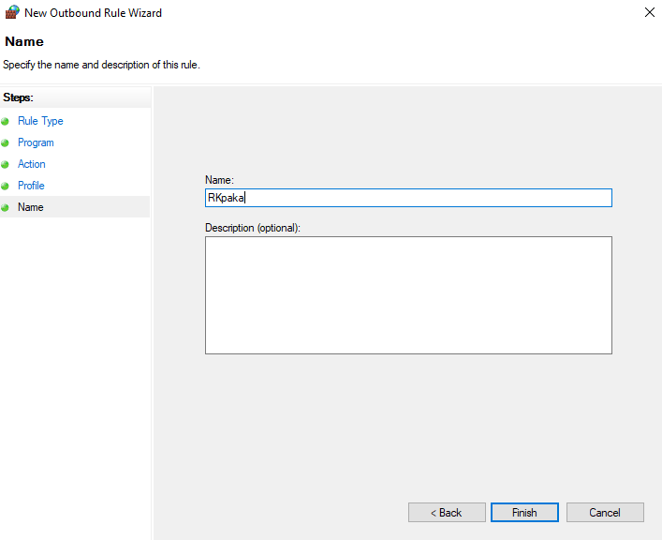

**Part 2.4 - Whitelisting Apps with Applocker**

1. Open Local Security Policy.

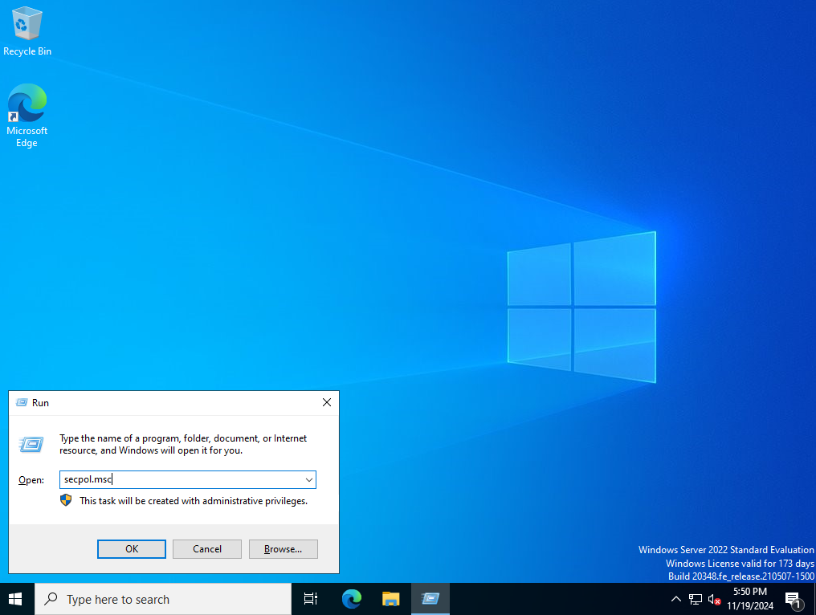

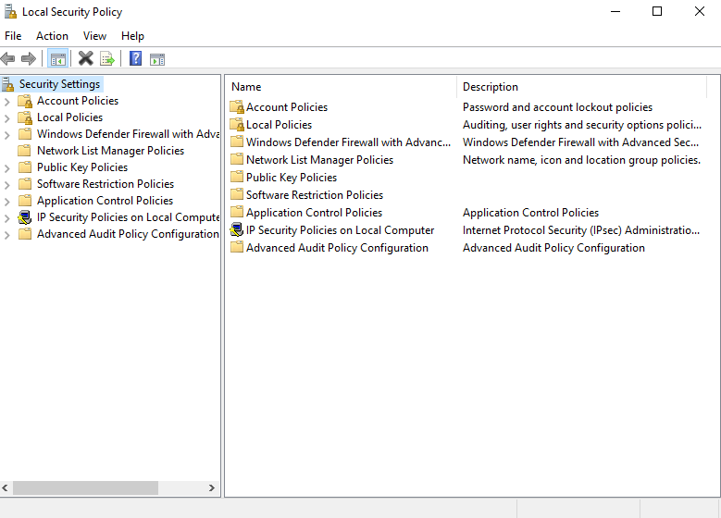

1. Navigate to Application Control Policies > AppLocker.

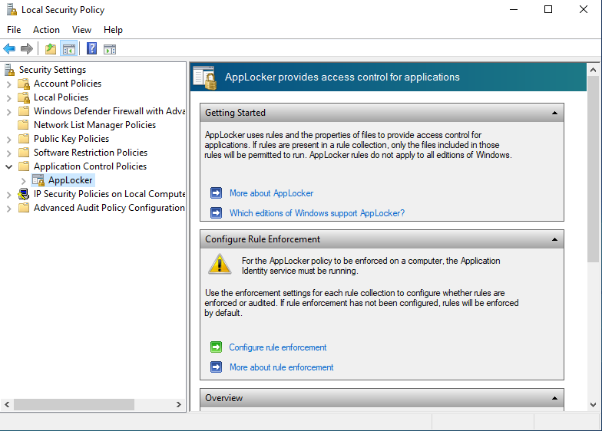

1. Create a rule to whitelist a specific app.

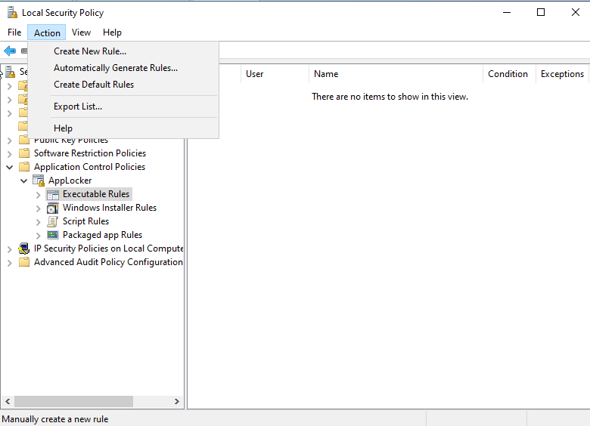

**Part 2.5 - Disk Imaging with Macrium Reflect**

1. Install and open Macrium Reflect.
2. Select the disk to image, configure the backup, and start the imaging process.